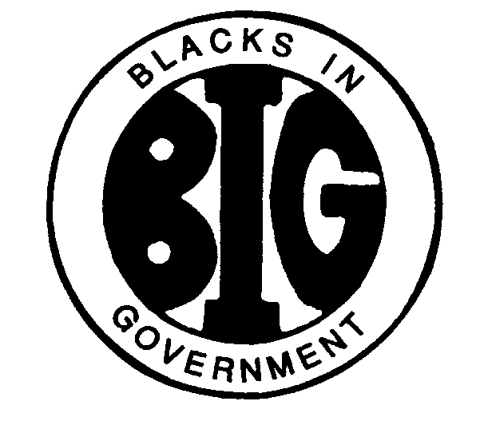
REGION IV BLACKS IN GOVERNMENT
ALABAMA FLORIDA GEORGIA KENTUCKY MISSISSIPPI
NORTH CAROLINA SOUTH CAROLINA TENNESSEE

2021 EXECUTIVE COMMITTEE MEETING

REGION IV MEMEMBERSHIP COMMITTEE
09 October 2021

Name: Ruby Dunson
E-Mail Address: rdunson1@cox.net / rubydunson57@gmail.com
Cell Phone: 850-217-6748

Committee members:

Ms. Earnestine M. Taylor-Jones, Albany Area Chapter
Ms. Patty Crawford, Albany Area Chapter
Ms. Shekita Maxwell, Atlanta Metro Chapter
Dr. Wilda Parker Collins, CDC/ATSDR
Ms. Andrea Rolle, Central Florida Chapter
Dr. Janice Boss, Greater Memphis Area
Ms. Cardell Hunt, Kings Bay Area
Mr. Prince Stokley, Kings Bay Area
Ms. BJ Parker, Kings Bay Area
Ms. Teresa Wright, Kings Bay Area
Ms. Beverly Duck-Davis, Magnolia Chapter
Ms. Katie Course, Magnolia Chapter
Ms. Angela Brown, Port City Chapter
Ms. Doris Settle Maxwell, Raleigh Durham Chapter
Ms. Kimberly Peterson, Raleigh Durham

Committee members consists of Region IV Chapter Presidents, Membership Chairs or Members.

I. RESPONSIBILITIES
The Membership Committee shall develop a comprehensive and ongoing general program for the Region addressing chapter formation, recruitment, and accountability of all regional chapter members.

II. ACTION ITEMS

NONE

III. ACTIVITIES

- Attended National 1st Virtual Regional Membership Chairs Meeting.
- Host Region IV Membership Committee Quarterly Conference Call Meeting.
- Attended National Membership Committee Virtual Chapter Membership Training.
- Assist and direct potential new members to the appropriate Chapter Presidents at the request of National Membership Chair to join Blacks In Government (BIG).
- Attended National Virtual Annual Membership Drive Events for the Month of May.
- Attended National Membership Committee Chapters Membership Training. (2)
- Emailed National Membership Communication’s emails to Region IV Chapters Presidents and Membership Chairs.
- Attended Virtual Region IV Training Conference (RTC).
- Region IV Current Membership status as of July 2021; 771 members per National Impexium Membership database.
- Participated National Virtual Membership Training for Region IV.

IV. CONCERNS/FYI

- Region IV Membership Incentives Program to Recruit, Reclaim and Retain members.
- Region IV Membership Committee recommendation to initiate an annual Region IV Training Conference (RTC) Training Assistance Program for members within Region IV. (If you have any suggestions, please contact any member on the membership committee).
- Recommendation to initiate Region IV Meet & Greet – Welcome new members and overall overview of BIG.
- Region IV Membership Committee recommendation to include a Membership drive in every event hosted by Region IV.

V. INVITATIONS & EVENTS

- Region IV Executive Council Virtual Meeting, 26 January 2021
- Region IV Chapter President’s Virtual Meeting, 25 February 2021
- Okaloosa County Chapter Virtual 2021 Youth Oratorical Competition, 20 March 2021
- National Regional Membership Chairs Virtual Meeting, 27 March 2021
- Region IV Membership Committee Conference Call Meeting, 29 Apr 2021
- National Kick Off Annual Month of May Membership Drive Virtual Events, 1 May, 8 May & 15 May 2021
- National Membership Committee Final Upcoming Annual Month of May Membership Drive Event, 22 May 2021 (BIG Benefits; Panel Discussion). See attached flyer.
- National Membership Committee Chapters Membership Virtual Training, 12 May 2021.
- Region IV Executive Committee Virtual Meeting, 20 May 2021
- Region IV Training Conference (RTC), 12 June 2021
- Region IV Executive Committee Virtual Meeting, 17 June 2021
- National Membership Committee Virtual Meeting, 17 June 2021
- National Membership Committee Chapters Virtual Training – 22 June 2021
- Chapter Presidents Second Virtual Meeting, 24 June 2021
- Region IV Spring Council Meeting, 26 June 2021
- National Training Institute (NTI), 23 – 26 August 2021
- National Membership Recognition, 25 August 2021
- National Membership Committee Virtual Training for Region IV, 25 September 2021

