BIG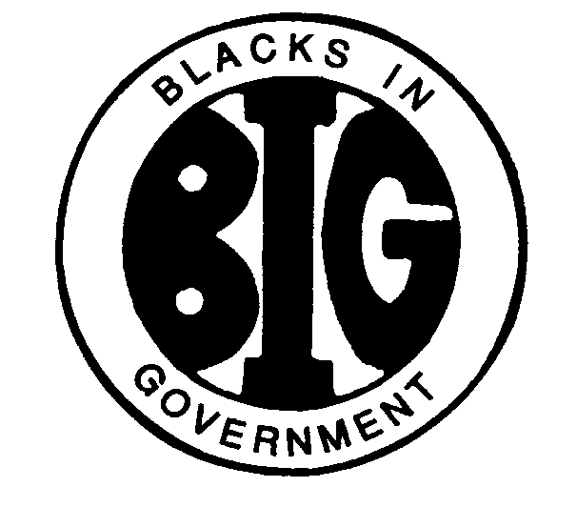
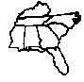
REGION IV BLACKS IN GOVERNMENT
ALABAMA FLORIDA GEORGIA KENTUCKY MISSISSIPPI
NORTH CAROLINA SOUTH CAROLINA TENNESSEE

2021 EXECUTIVE COMMITTEE MEETING

REGION IV 1ST VICE PRESIDENT
October 9, 2021

Name: Ruby Dunson
E-Mail Address: rdunson1@cox.net / rubydunson57@gmail.com
Cell Phone: 850-217-6748

I. RESPONSIBILITIES
Shall perform all the duties and functions of the Regional Council President in the event the Regional Council President and Executive President Vice President are absent or incapacitated. During such a period, the Vice President shall have all the powers and be subject to all the restrictions of that office. This includes countersign with the Treasurer or Assistant Treasurer check s drawn on the Regional Council Treasury. In addition, each Vice President shall be responsible, respectively, for serving as a focal point and coordinating programs and activities relating to one of the following sectors: federal, state, and local. They shall perform such other duties as may be assigned by the Regional Council President.

II. ACTION ITEMS

NONE

III. ACTIVITIES

Participated in Blacks In Government, Inc. 42nd Virtual National Training Institute, First Vice President “Virtual 2021 Federal Forum; Safety in the Federal Workplace.” 25 August 2021 (Attached flyer).

IV. CONCERNS/FYI

NONE

V. INVITATIONS & EVENTS

- Attended Region IV Executive Council Virtual Meeting, 26 January 2021
- Attended Region IV Chapter President’s Virtual Meeting, 25 February 2021
- Attended Okaloosa County Chapter Virtual 2021 Youth Oratorical Competition, 20 March 2021
- Attended Virtual BIG Orientation National President Honorable Shirley A. Jones, Esq., 1 May 2021
- Attended First Vice President, National First Round Table Tele-Conference Call Meeting, 4 May 2021
- Attended Virtual Executive Committee Meeting, 7 May 2021
- Attended Virtual Annual Membership Drive Event Retired Cecil Haney & The National Committee, 8 May 2021
- Attended Virtual Annual Membership Drive Event Advocacy with Rev. Jamar Jackson, 15 May 2021
- Attended Virtual Executive Committee Meeting, 20 May 2021
- Attended Virtual Region IV Training Conference (RTC), 12 June 2021
- Attended First Vice President National Tele-Conference Call Meeting, 14 June 2021
- Executive Committee Virtual Meeting, 17 June 2021
- Region IV Spring Council Meeting, 26 June 2021
- First Vice President National Tele-Conference Call Meeting, 29 June 2021
- Attended First Vice President National Tele-Conference Call Meeting, 15 July 2021
- Attended First Vice President National Tele-Conference Meeting, 4 August 2021
- Attended 2021 Delegate Assembly Training, 10 August 2021
- Attended Region IV Virtual Youth Competition, 14 August 2021
- Attended First Vice President Virtual Meeting, 17 August 2021
- Attended 2021 National Delegates Assembly, 22 August 2021
- Attended 2021 National Training Institute (NTI), 23 – 26 August 2021
- Attended NAACP Virtual Economic Summit, 7 September 2021
- Attended BIG National Youth Competition, 11 September 2021
- Attended National Membership Committee Virtual Training for Region IV, 25 September 2021
- Plan to attend Executive Committee Virtual meeting, 6 October 2021
- Plan to attend 2021 Virtual Fall Council meeting, 9 October 2021

