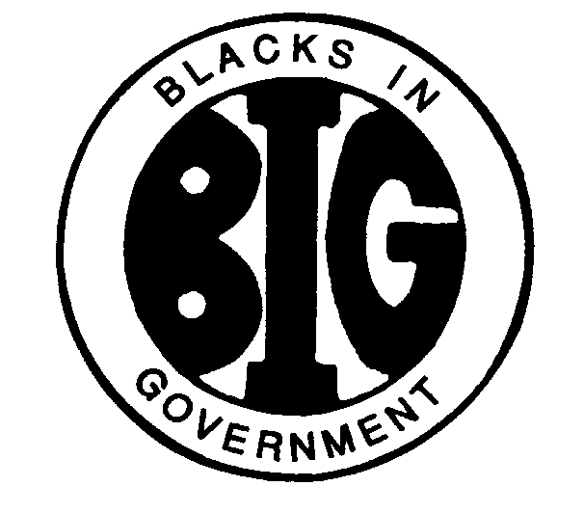
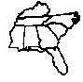
REGION IV BLACKS IN GOVERNMENT
ALABAMA FLORIDA GEORGIA KENTUCKY MISSISSIPPI
NORTH CAROLINA SOUTH CAROLINA TENNESSEE

Region IV Health & Wellness Coordinator

Health and Wellness Update
September 30, 2021

Name: Mary L. Beal
E-Mail Address: mlbeal.mb@gmail.com
Cell Phone: (229) 401-8308

I. RESPONSIBILITIES

Health and Wellness. The Health and Wellness Committee shall develop and coordinate comprehensive on-going activities that educate the general membership on health care access, prevention, treatment, insurance, finding opportunities and health risk factors that affect the African American community; increase the level of awareness and understanding of initiatives on the elimination of race and ethnic health disparities nationwide; exchange information on healthy lifestyles that lead to reducing the risk of HIV/AIDS, diabetes, cardiovascular diseases, cancer, homicide, mental disorder, lupus, obesity, and infant mortality; help to foster partnerships within the African- American communities, including survivors.

II. ACTION ITEMS

None.

III. ACTIVITIES

- Drafted informational health and wellness workshop via monthly ZOOM.

- Issue monthly health and wellness polls to obtain information to substantiate proposed Health and Wellness training topics.

- Partner with organizations (churches, fraternities, sororities, masonic, NAACP, etc.) at the state and national level on publicity and training opportunities on Health & Wellness. Formulating a schedule to conduct ZOOM meeting monthly to share health and wellness information.

- Joined the local health and wellness coalition.

- Develop evaluation guidelines to measure effectiveness of initiatives.

- Recruit volunteers to work on a Health & Wellness Committee

- Develop a Webinar Targeting At-Risk population in all states within Region IV

- Participate in Department of Public Health (DPH) Health Fair

IV. CONCERNS / FYI

- Outreach to Chapters/Members
- Limited travel, low level of digital literacy, social distancing
- The level of Health and Wellness Advocacy

V. INFORMATION AND HEALTH AND WELLNESS RESOURCES

1. Virtual Training – Health and Wellness Seminars (On Demand)
a. The Usual Suspects - Common Nutrient Deficiencies that Cause BIG Problems
https://live.carebeyond.com/on-demand/improve-health/play.php?v=usual-suspects&site=340562

b. Immune System Grand Slam
https://live.carebeyond.com/on-demand/improve-health/play.php?v=grand-slam&site=340562

c. Gut Health First – Natural Solutions to Health Problems
https://live.carebeyond.com/on-demand/improve-health/play.php?v=gut-first&site=340562

2. Please complete the attached health and wellness poll and return to me by 31 October 2021 at mlbeal.mb@gmail.com or P.O. Box 1064 Cordele, GA 31010

3. COVID-19 Statistical Update

